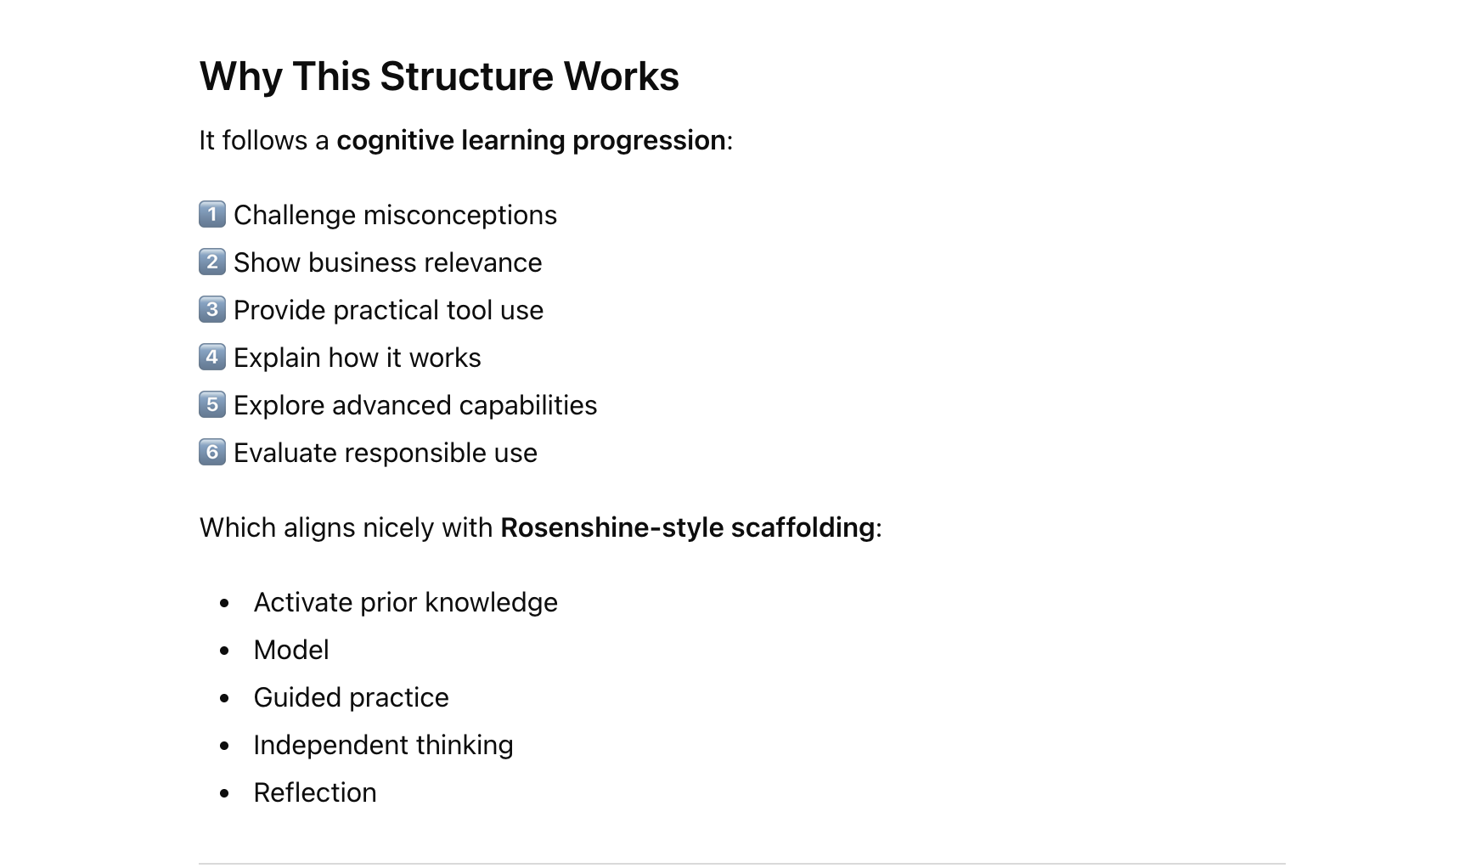

AI for Businesses – One Day Practical Training
Work smarter, save time and feel confident using AI at work
This flow integrates:
- early hands-on AI use
- SME-focused productivity tasks
- business discussion
- technical understanding
- reflection and support

Course Flow

1. Opening and Introductions
Time: 20 minutes
Learning outcomes: 1, 3, 6

Activity: AI-Assisted Introductions
Tool: Microsoft Teams Copilot
Participants introduce themselves:
- name
- business/role
- What they would like to gain from today
Recording and transcription enabled.

Copilot Demonstration
Display AI outputs:
- meeting summary
- key topics
- suggested actions
Discussion:
- Did AI summarise accurately?
- What did it miss?
- Would this help in your workplace?
Key idea
AI is already embedded in common business tools.

2. Early Practical Exercise – AI Productivity Challenge
Time: 30 minutes
Learning outcomes: 2, 3
Participants immediately use AI tools to complete three realistic SME tasks.
Possible tools:
- ChatGPT
- Gemini
- Claude

Tasks
Email task
Write a professional email explaining a delivery delay.
Marketing task
Create a short social media post promoting a local business offer.
Website task
Generate a short homepage description for a small business.

Reflection
Participants consider:
- Did AI save time?
- What edits were needed?
- Would you use the output in your business?
This acts as a diagnostic assessment of confidence and critical use of AI.

3. AI vs Not AI
Time: 20 minutes
Learning outcome: 1

Activity: AI vs Not-AI Voting
Examples:
Example | AI?
Spotify recommendations | AI
Excel SUM formula | Not AI
Fraud detection systems | AI
Digital thermostat | Not AI
Purpose:
- clarify misconceptions
- distinguish automation from AI

4. Business Context – Frontier Firms
Time: 25 minutes
Learning outcomes: 4, 6

Concept: Frontier Firms
A frontier firm integrates AI deeply into everyday workflows, enabling small teams to achieve productivity levels previously only possible for large organisations.
Examples:
- marketing agencies using AI for content generation
- small retailers using AI analytics
- consultants using AI research tools

Activity
Participants identify three tasks in their business where AI could help.
Examples:
- customer emails
- social media content
- reports
- spreadsheets
- scheduling

5. Comparing AI Tools
Time: 45 minutes
Learning outcomes: 2, 3

Activity: AI Model Comparison
Participants test the same prompt in multiple tools:
- ChatGPT
- Gemini
- Claude
Example prompt:
Create a simple marketing plan for a new hair salon targeting university students.
Participants compare results:
Criteria | Tool A | Tool B | Tool C
Creativity
Clarity
Accuracy
Usefulness
Discussion:
- strengths of different models
- importance of prompt design

6. AI Productivity Workflows
Time: 45 minutes
Learning outcome: 3
Demonstrate practical SME uses:
- summarising documents
- rewriting emails
- creating social media campaigns
- extracting actions from meeting notes
- analysing spreadsheet data

Activity
Participants use AI to:
- summarise a messy report
- extract key actions
- convert it into an email

Lunch Break

7. How AI Actually Works (Simple Explanation)
Time: 35 minutes
Learning outcome: 5
Explain key ideas without technical jargon:
- neural networks
- transformer models
- embeddings
Example:
Words exist in a vector space of meaning, where similar words appear close together.
Example clusters:
dog – cat
king – queen
car – truck
This enables:
- chatbots
- search tools
- recommendation systems

8. Exploring AI Agents
Time: 35 minutes
Learning outcomes: 3, 6

Activity: Experiment with an AI Agent
Example tool:
AgentGPT
https://agentgpt.reworkd.ai/
Participants define a goal such as:
Research marketing strategies for a small local café.
They observe:
- task planning
- automated research
- iterative reasoning
Discussion:
- benefits
- limitations
- need for human oversight

9. Human vs AI Business Simulation
Time: 40 minutes
Learning outcomes: 4, 6

Activity: Human vs AI Hairdressing Business Simulator
Two teams:
AI Team
Uses AI tools to make business decisions.
Human Team
Uses experience and judgement.
Decisions include:
- pricing strategy
- marketing approach
- staffing
- services offered
Compare outcomes:
Metric | Human | AI
Profit
Customer growth
Marketing reach
Discussion:
- when AI helps
- when human judgement matters

10. Networking and Individual AI Support Session
Time: 30 minutes
This final session gives participants time to:
- ask individual questions
- try AI tools on their own business tasks
- discuss ideas with other attendees

Possible activities
Participants may:
- test AI prompts for their business
- refine marketing or website content
- explore AI tools relevant to their industry
- discuss ideas with peers

Facilitator role
Provide support by helping participants:
- improve prompts
- identify suitable AI tools
- evaluate outputs critically

Outcome
Participants leave with:
- practical ideas for applying AI in their workplace
- new professional connections
- confidence to start using AI immediately

Summary of the Day
Stage | Focus | Key Activity
Opening | AI in everyday work | Teams Copilot demo
Early practical use | AI productivity | AI productivity challenge
Understanding AI | AI vs Not AI | voting activity
Business context | Frontier firms | task identification
Tools | Generative AI | model comparison
Productivity | workflows | document summarisation
Technical understanding | how AI works | embeddings explanation
Advanced tools | AI agents | AgentGPT experiment
Evaluation | human vs AI | business simulator
Support | networking | individual AI guidance

If you'd like, I can also create:
- A full-day PowerPoint structure (60–70 slides)
- Ready-to-use prompts for each activity
- A printable workbook for participants

